## Tabular Data:

Here I am using the same project that I have created for Image classification AutoML.

1. Project id: hw2p1-image

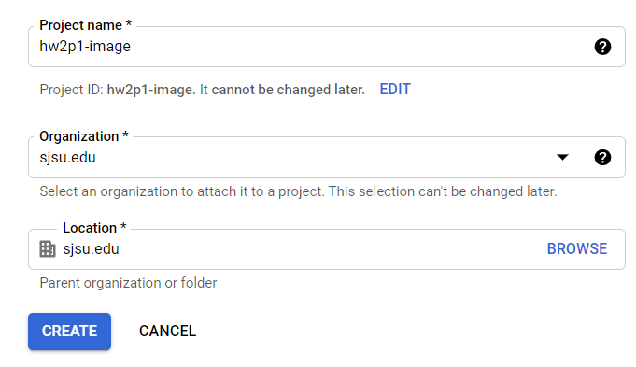

1. API is enabled

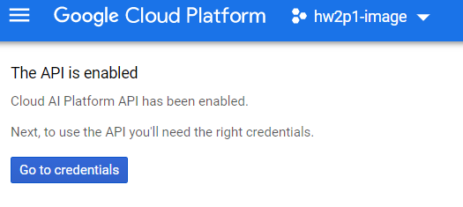

1. Authentication Setup

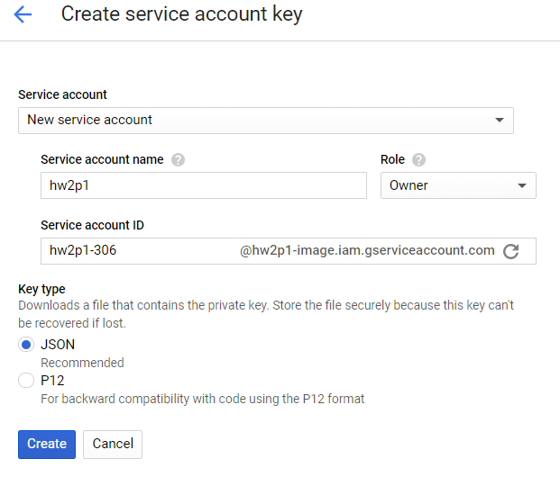

1. Set environment variable

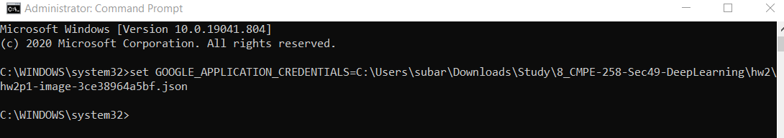

1. Cloud Console:

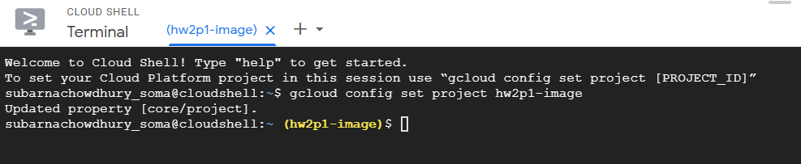

1. Create Dataset ‘Structured_AutoML_Tutorial’

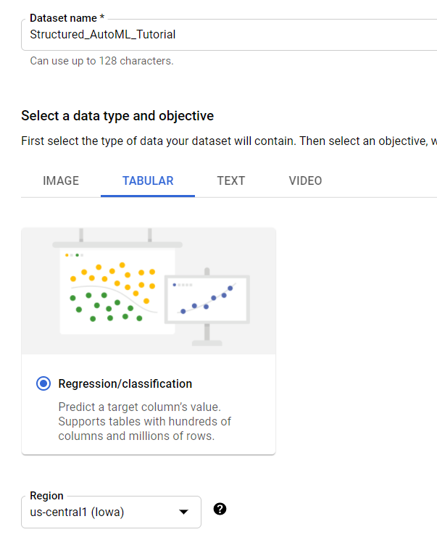

1. Import Data from Storage

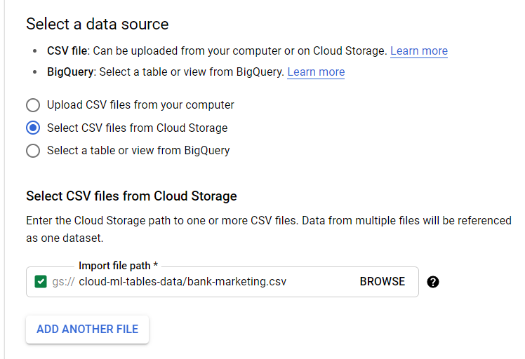

1. Analyze Pan:

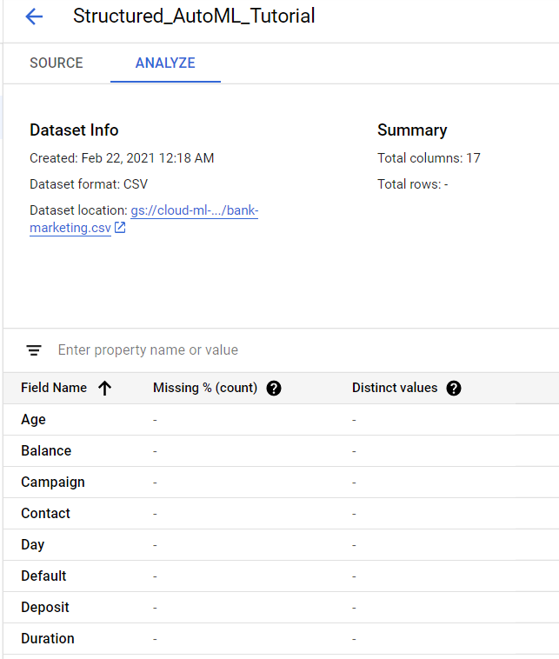

1. Generated Statistics

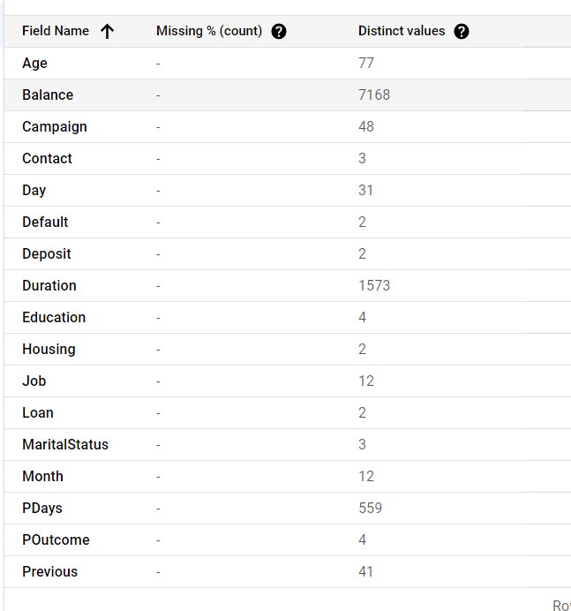

1. Selecting Training Model: Structured_AutoML_Tutorial

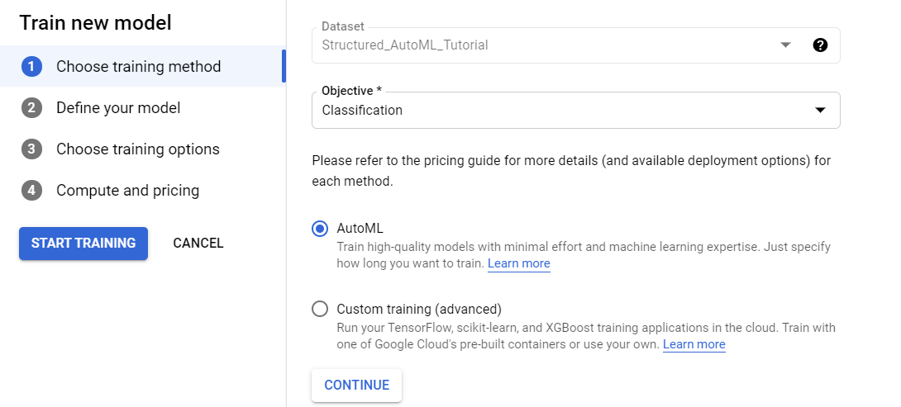

1. Defined the model:

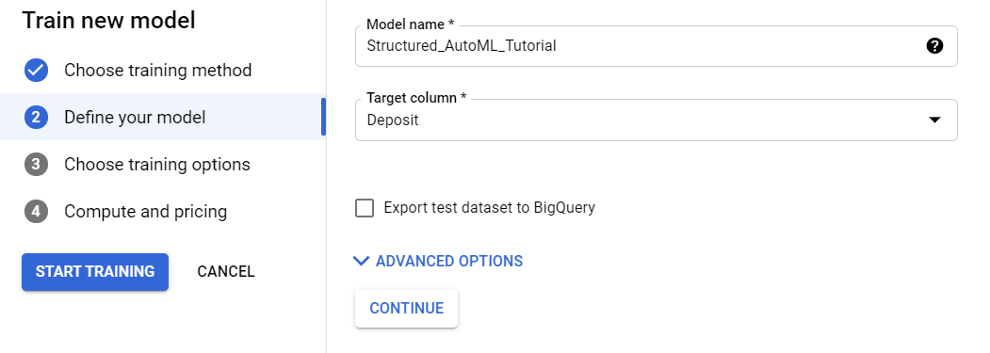

1. Training Budget

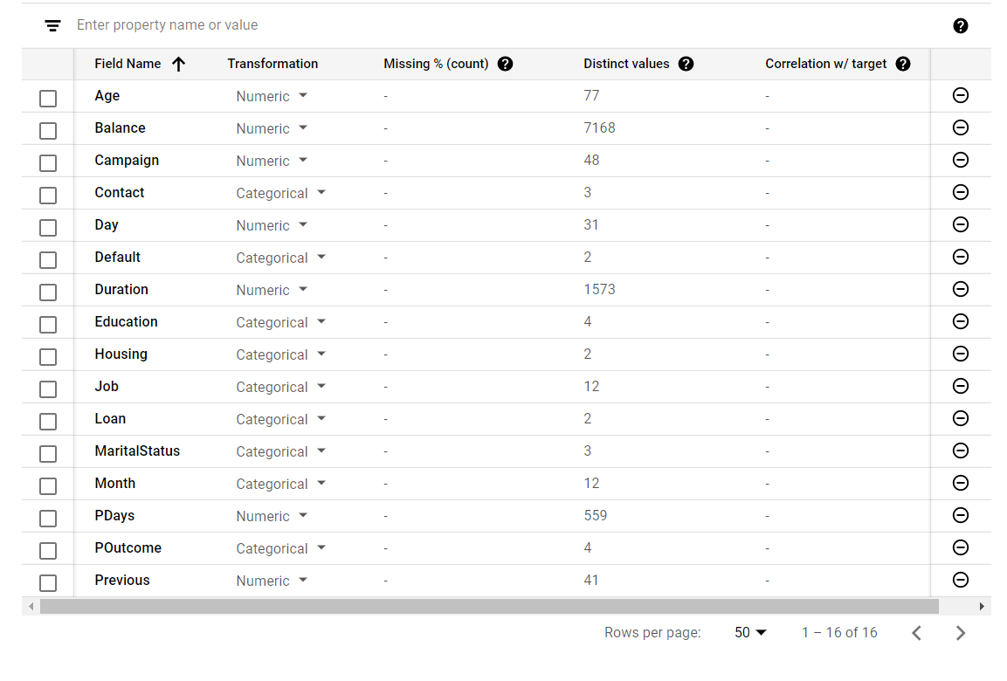

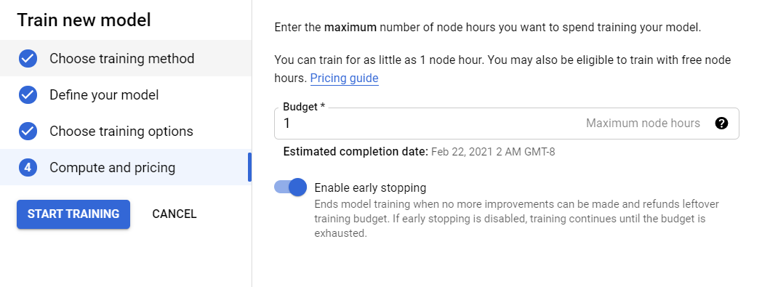

1. Got Email Notification about successful training

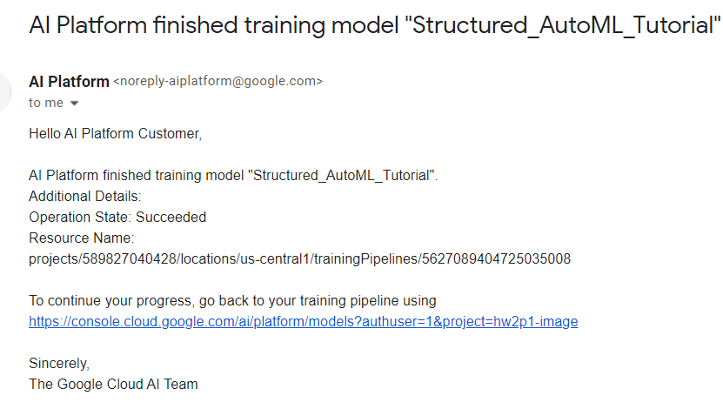

1. Trained Model: It has taken 1+ hours to train



1. Evaluation

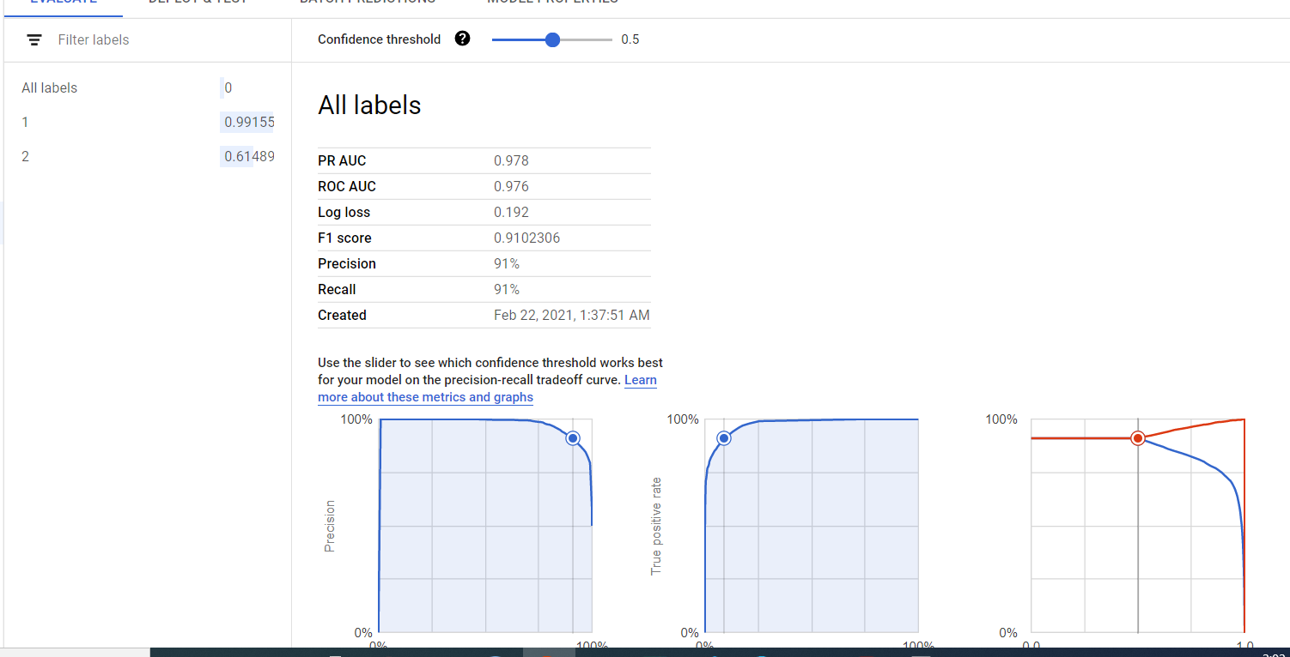

1. Confusion Matrix

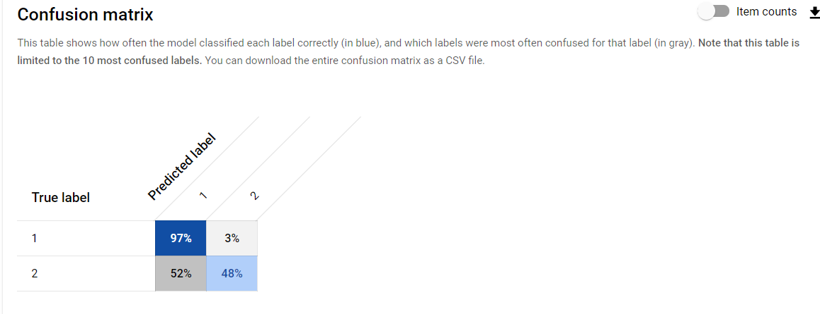

1. Feature Importance :

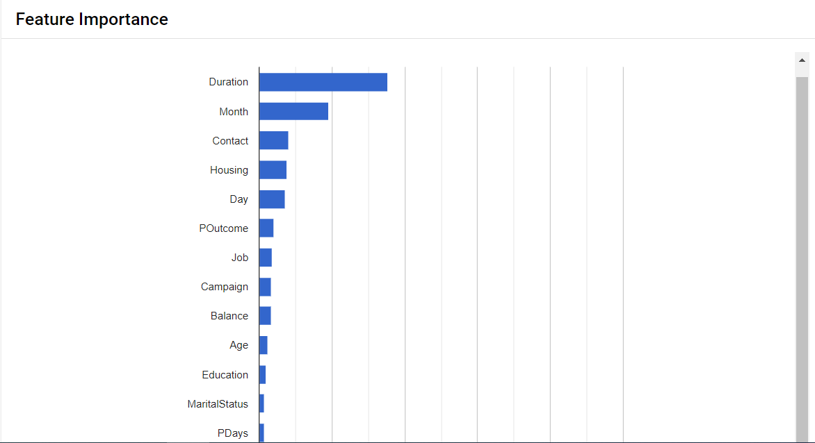

1. Created Deployment Endpoint ‘Structured_AutoML_Tutorial’

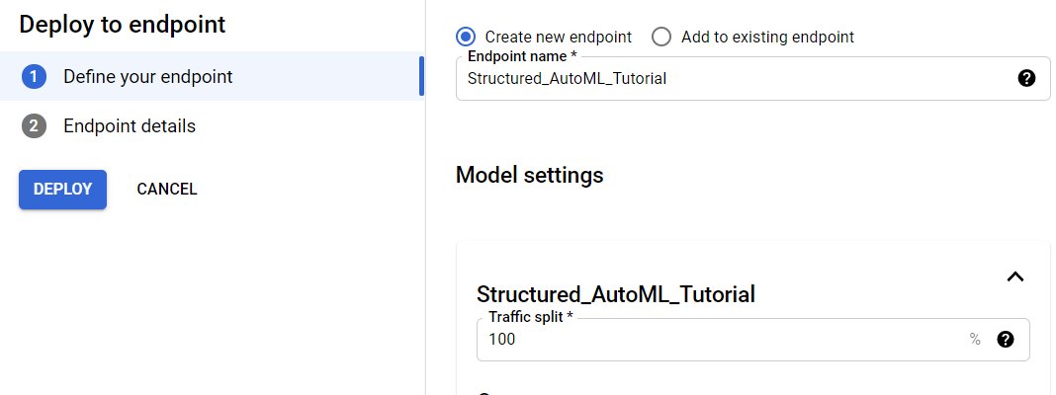

1. Successful Deployment

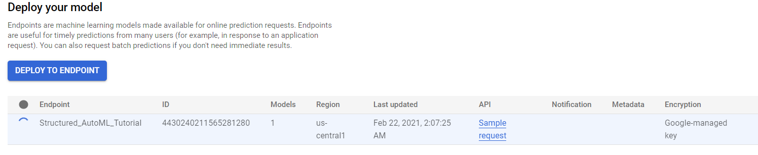

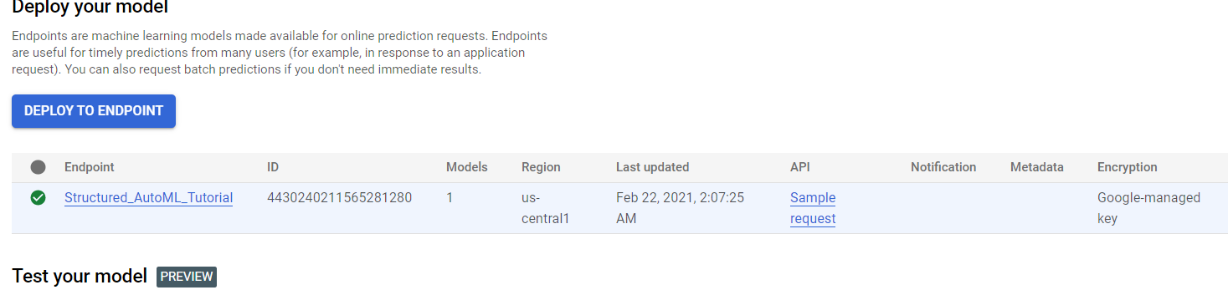

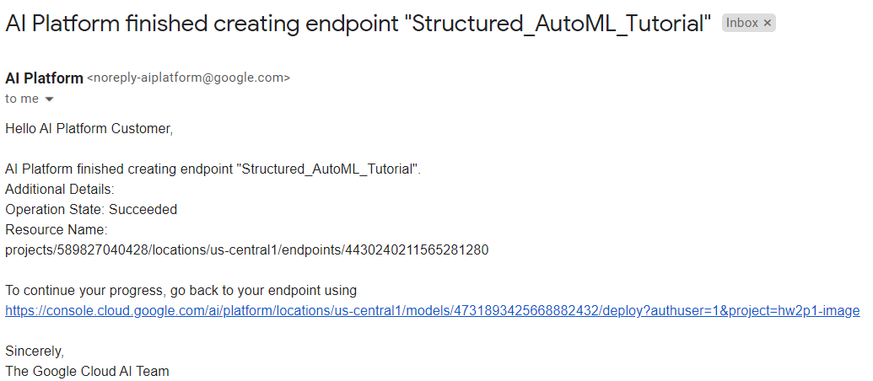

1. Prediction 100% Correct

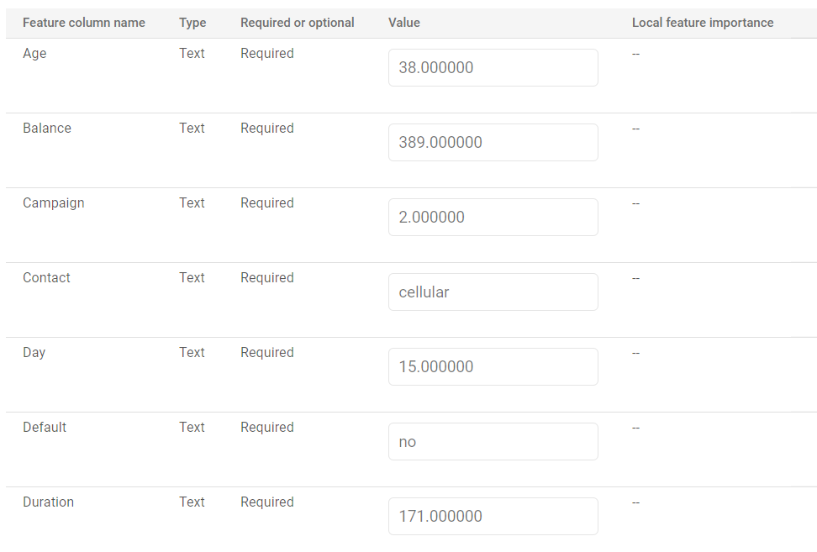

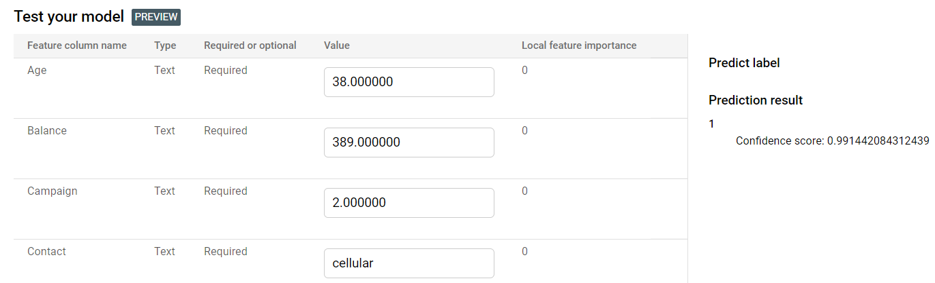

1. Removed Storage

